______________________________________________________________

UM-SJTU JOINT INSTITUTE

PHYSICS LABORATORY

(VP 241)

______________________________________________________________

LABORATORY REPORT

EXERCISE 3

SOLAR CELLS: *I-V* CHARACTERISTICS

|  |  |  |
| --- | --- | --- |
| **Name: Weikai Zhou** | **ID: 518021911039** | **Group: 8** |
| Name: Yingtao Zou | ID: 518370910069 | Group: 8 |
|  |  |  |
| Date: 25 October 2019 |  |  |

1. **Introduction**
   1. **Objectives**

* Get familiar with the working principle of a solar cell
* Study the current-voltage (*I-V*) characteristics
  1. **Theoretical background**

Solar cells can directly transform solar radiation into electrical energy. No consumption of energy, silent operation, no moving parts, a long lifetime and so on are their advantages. Moreover, it is easy to maintain solar cells and they do not pollute air. Therefore, they are thought to be a promising energy source in the 21st century and people hope that by the mid-21st century, solar cells will produce 15–20% of the total electrical energy generated in the world. After that, solar energy will become one of the leading energy sources.

* + 1. **Solar cell structure**

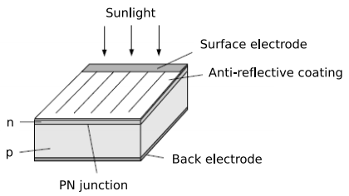As shown in Figure 1, a crystalline silicon solar cell consists of *n*/*p* homo-junctions, a 10 cm × 10 cm *p*–type silicon plate of thickness 500 *µ*m, covered with a heavily doped *n*-type layer with thickness 0.3 *µ*m. The function of the metallic bars on the *n­*-type layer is one electrode, while a metallic film at the bottom serves the role of another one. An anti-reflective film is often applied to cover the surface exposed to sunlight so that we can reduce the loss of energy due to reflection.

Figure 1. Structure of a crystalline silicon solar cell

* + 1. **Photovoltaic effect**

When the light enters the *p-n* junction, if the energy of incident photons is greater than the forbidden bandwidth, which can be also called as energy gap, $E_{g}$, the incident photons are absorbed and excite electron-hole pairs. Minority charge carriers in the *n*- or *p*-type area diffuse because of the density gradient. Some of them can diffuse to the region of the *p-n* junction and there is a built-in electric field. The direction of this field is from the *n*-type to the *p*-type area. This electric field will draw the carriers which are diffused to the *p-n* junction zone between the *n*-type area and the *p*-type area to the *p*-type area (in case of the holes), or to the *n*-type area (in case of the electrons). Therefore, more positive charge will accumulate in the *p*-type area and negative charge accumulate in the *n*-type area. Finally, there will form a photoelectric potential difference.

* + 1. **Solar cell parameters**

Based on photovoltaic effect, electric current $I_{ph}$ will be generated by solar cells from the *n*–type area to the *p*-area when there is light which is large enough incident on the solar cell.

Meanwhile, there is a forward diode current $I_{D}$ from the *p*-type to the *n*-type area, which is opposite to $I_{ph}$. Then, we can calculate the net current as

$I=I_{ph}-I_{D}=I_{ph}-I_{0}\left[exp\left(\frac{qV_{D}}{nk_{B}T}\right)-1\right],$ (1)

where $I_{0}$ is the diode inverse saturation current, $V_{D}$ is the junction voltage, and $I_{ph}$ is the photocurrent determined by the structure and material characteristics of the solar cell. *n* is a theoretical coefficient characterizing the *p-n* junction, with its values ranging from 1 to 2. Furthermore, *q* denotes the electron’s charge, $k_{B}$ is the Boltzmann’s constant, and *T* is the temperature in the absolute (Kelvin) scale. If we ignore the internal series resistance $R_{s}$, the voltage $V_{D}$ equals the terminal voltage *V* and Eq. (1) can be rewritten in another form

$I=I_{ph}-I_{0}\left[exp\left(\frac{qV}{nk_{B}T}\right)-1\right]$.

When *V* = 0, the short-circuit current is

$I_{sc}=I_{ph}$.

whereas *I* = 0, the open-circuit voltage is

$V_{oc}=\frac{nk_{B}T}{q}ln\left(\frac{I_{sc}}{I_{0}}+1\right)$.

When there is a load resistance *R* ranging from 0 to $∞$, the corresponding *I–V* characteristics curve is shown in Figure 2. For a certain load resistance $R=R_{m}$, if we know that the maximum output power $P_{m}$ is generated, then we can calculate it as

$P_{m}=I_{m}V_{m}$,

where $I_{m}$ and $V_{m}$ are the optimal operating current and the optimal operating voltage respectively. Then we introduce a new term, which is called the *fill factor* (*FF*).

$FF=\frac{P_{m}}{V_{oc}I_{sc}}=\frac{V_{m}I_{m}}{V_{oc}I_{sc}}$.

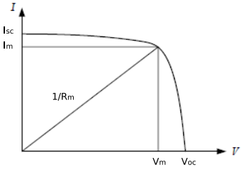The greater it is, the greater the output power. It depends on numeric factors, like the forbidden bandwidth, the incident light intensity, the value of the theoretical coefficient *n*, and the series/parallel resistance.

Figure 2. The *I-V* characteristics of a solar cell

Next, we need to define the solar cell energy conversion efficiency *η*

$η=\frac{P_{m}}{P_{in}}×100\%$,

where $P_{in}$ represents the total radiant power incident on the solar cell.

* + 1. **Solar cell equivalent circuit**

Figure 3 has told us the information that a solar cell can be thought of as composed of a *p-n* junction diode *D* and a constant current source $I_{ph}$. All elements form a circuit equivalent to a *p-n* junction leak-circuit along with a series resistance $R_{s}$ and a parallel resistance $R_{sh}$. We can find the relationship between the current and the voltage through the equivalent circuit

$I=I_{ph}-I_{0}\left\{exp\left[\frac{q\left(V+R_{s}I\right)}{nk_{B}T}\right]-1\right\}-\frac{V+R_{s}I}{R_{sh}}$.

And we should decrease the value of $R_{s}$ and increase the value of $R_{sh}$ to provide a greater output power.

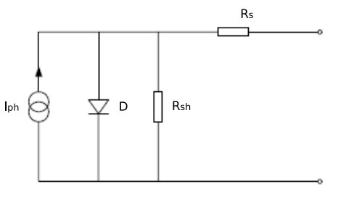Figure 3. Solar cell equivalent circuit

1. **Apparatus**
   1. **Experimental setup**

A photovoltaic device (5 W), a 300 W tungsten–halogen lamp serving as a radiation source, two digital multimeters, two adjustable resistors, a solar power meter, a wiring board and a measuring tape are the setup of this experiment.

* 1. **Precision or uncertainty**

|  |  |  |  |
| --- | --- | --- | --- |
| DC voltage | $±$ 0.5%+0.01 [V] | Distance | $±$ 0.1 [cm] |
| DC current | $±$ 1.5%+0.1 [mA] | Solar power | 10 [W/m2] |

Table 1. Precision or uncertainty of the equipment

1. **Measurement procedure**
   1. We should first turn on both the light and the fan, and wait for at least five minutes, so that the light can reach its working intensity.
   2. Then, we should design a measuring circuit with the photovoltaic device, multimeters set in an appropriate range and the resistance, and connect them into a circuit using the provided wiring board.
   3. Next, we should work in pairs. We should keep adjusting the distance between the light source and the photovoltaic device until the $V_{oc}$ and $I_{sc}$ of the two devices are about the same. Then, with the help of the solar power meter, we should measure the solar power.

We should change the resistance and measure the relevant current and voltage, so that we can collect the data to draw the *I–V* characteristics curve. We need to remember that keeping the distance between the light source and the photovoltaic device and not moving around the workstation during the measurement is important. Otherwise, the light intensity will not be maintained during the whole process.

Moreover, we should measure the *I-V* characteristics curves and the values of $V_{oc}$ and $I_{oc}$ under the following three conditions:

1. Two devices in series;
2. Two devices in parallel;
3. A single device.
   1. Then, we can change the distance between the light source and the photovoltaic device and measure the *I–V* characteristics curves and the values of $V_{oc}$ and $I_{sc}$ in a single-device configuration. We should pay attention that the new distance should be about 80% or 120% of the original distance. And we also need to measure the solar power at this distance.
   2. Finally, with the help of a computer, we can plot the *I–V* characteristics curves and the graph of the output power vs. the voltage. We then should try to determine the values of $I_{sc}, V_{oc}, P_{m}, I_{m}, V_{m}, R_{m}, FF$ and $η$. And we should compile the data in the form of a table.
4. **Results and discussion**

First, we record the precision of the equipment, as shown in Table 2.

|  |  |
| --- | --- |
| QUANTITY | PRECISION |
| DC voltage | $±$ 0.5%+0.01 [V] |
| DC current | $±$ 1.5%+0.1 [mA] |
| Distance | $±$ 0.1 [cm] |
| Solar power | 10 [W/m2] |

Table 2. Multimeter precision

Then we measure the length and width of the photovoltaic device, as shown in Table 3.

|  |  |
| --- | --- |
| Length [$±$ 0.1 cm] | Width [$±$ 0.1 cm] |
| 26.2 | 21.1 |

Table 3. Measurement data for area

Then we are able to calculate the area of the photovoltaic:

$$26.2×21.1=553±3cm^{2}$$

|  |  |  |  |  |  |  |
| --- | --- | --- | --- | --- | --- | --- |
|  | 1 | 2 | 3 | 4 | 5 | 6 |
| [10 W/m2] | 161.8 | 172.9 | 185.6 | 169.0 | 177.8 | 181.5 |
| [10 W/m2] | 195.8 | 198.3 | 194.3 | 196.6 | 194.8 | 197.9 |

Table 4. Measurement data for solar power

Then, we can calculate the average value of solar power measurements:

$$\overline{P_{131.0}}=\frac{1}{6}\sum_{i=1}^{6}{P_{i}}=174.8±13.5 W/m^{2}$$

$$\overline{P_{100.3}}=\frac{1}{6}\sum_{i=1}^{6}{P_{i}}=196.3±10.1 W/m^{2}$$

Therefore, we can get

$$P_{in1}=553×{10}^{-4}×174.76=9.7±0.7 W$$

$$P_{in2}=553×{10}^{-4}×196.28=10.9±0.6 W$$

Then, we measured the open circuit voltage and short circuit current for the single device at 131.0 cm, single device at 100.3 cm, series connected and parallel connected. The data is shown in Table 5.

|  |  |  |  |  |
| --- | --- | --- | --- | --- |
|  | Single device at 131.0 cm | Single device at 100.3 cm | Series | Parallel |
| $U_{oc}$ [V] | 9.01 $±$ 0.06 | 9.58 $±$ 0.06 | 16.28 $±$ 0.09 | 8.24 $±$ 0.05 |
| $I_{sc}$ [mA] | 49.8 $±$ 0.8 | 81.3 $±$ 1.3 | 47.4 $±$ 0.8 | 90.8 $±$ 1.5 |

Table 5. Measurement data for $U_{oc}$ and $I_{sc}$

Then, we change the resistance and measure the relevant current and voltage. The result is listed in Table 6 and 7.

|  |  |  |  |  |  |  |  |  |
| --- | --- | --- | --- | --- | --- | --- | --- | --- |
|  | Series | | | | Parallel | | | |
|  | *U* [V] | $u_{U}[±$ V] | *I* [mA] | $u_{I}$ [$±$ mA] | *U* [V] | $u_{U}[±$ V] | *I* [mA] | $u_{I}$ [$±$ mA] |
| 1 | 0.05 | 0.01 | 47.1 | 0.8 | 0.83 | 0.01 | 90.2 | 1.5 |
| 2 | 1.52 | 0.02 | 45.5 | 0.8 | 1.26 | 0.02 | 88.4 | 1.4 |
| 3 | 2.08 | 0.02 | 44.9 | 0.8 | 1.81 | 0.02 | 86.2 | 1.4 |
| 4 | 2.50 | 0.02 | 44.4 | 0.8 | 2.32 | 0.02 | 83.6 | 1.4 |
| 5 | 3.21 | 0.03 | 43.6 | 0.8 | 2.82 | 0.02 | 80.9 | 1.3 |
| 6 | 4.13 | 0.03 | 42.5 | 0.7 | 3.06 | 0.03 | 79.7 | 1.3 |
| 7 | 5.21 | 0.04 | 41.1 | 0.7 | 3.22 | 0.03 | 78.7 | 1.3 |
| 8 | 6.33 | 0.04 | 39.7 | 0.7 | 3.36 | 0.03 | 77.6 | 1.3 |
| 9 | 7.24 | 0.05 | 38.6 | 0.7 | 3.52 | 0.03 | 76.5 | 1.2 |
| 10 | 8.03 | 0.05 | 37.6 | 0.7 | 3.71 | 0.03 | 74.8 | 1.2 |
| 11 | 8.40 | 0.05 | 37.1 | 0.7 | 3.93 | 0.03 | 73.3 | 1.2 |
| 12 | 8.82 | 0.05 | 36.3 | 0.6 | 4.08 | 0.03 | 72.1 | 1.2 |
| 13 | 9.17 | 0.06 | 35.5 | 0.6 | 4.25 | 0.03 | 70.5 | 1.2 |
| 14 | 9.53 | 0.06 | 34.7 | 0.6 | 4.37 | 0.03 | 69.3 | 1.1 |
| 15 | 9.93 | 0.06 | 33.8 | 0.6 | 4.57 | 0.03 | 68.1 | 1.1 |
| 16 | 10.30 | 0.06 | 32.9 | 0.6 | 4.71 | 0.03 | 66.7 | 1.1 |
| 17 | 10.63 | 0.06 | 31.9 | 0.6 | 4.88 | 0.03 | 65.3 | 1.1 |
| 18 | 10.89 | 0.06 | 31.1 | 0.6 | 5.13 | 0.04 | 63.2 | 1.0 |
| 19 | 11.23 | 0.07 | 29.9 | 0.5 | 5.41 | 0.04 | 60.5 | 1.0 |
| 20 | 11.52 | 0.07 | 28.9 | 0.5 | 5.78 | 0.04 | 56.8 | 1.0 |
| 21 | 11.94 | 0.07 | 27.2 | 0.5 | 6.19 | 0.04 | 51.7 | 0.9 |
| 22 | 12.44 | 0.07 | 25.2 | 0.5 | 6.66 | 0.04 | 45.5 | 0.8 |
| 23 | 13.07 | 0.08 | 22.5 | 0.4 | 7.17 | 0.05 | 35.5 | 0.6 |
| 24 | 13.76 | 0.08 | 19.1 | 0.4 | 7.59 | 0.05 | 24.3 | 0.5 |
| 25 | 14.50 | 0.08 | 14.7 | 0.3 | 8.06 | 0.05 | 8.1 | 0.2 |

Table 6. Measurement data for the *U* vs. *I* relation (series/parallel configuration)

|  |  |  |  |  |  |  |  |  |
| --- | --- | --- | --- | --- | --- | --- | --- | --- |
|  | 131.0 cm | | | | 100.3 cm | | | |
|  | *U* [V] | $u_{U}[±$ V] | *I* [mA] | $u_{I}$ [$±$ mA] | *U* [V] | $u_{U}[±$ V] | *I* [mA] | $u_{I}$ [$±$ mA] |
| 1 | 0.69 | 0.01 | 49.6 | 0.8 | 0.46 | 0.01 | 80.7 | 1.3 |
| 2 | 1.09 | 0.02 | 49.0 | 0.8 | 1.04 | 0.02 | 79.5 | 1.3 |
| 3 | 1.70 | 0.02 | 48.2 | 0.8 | 1.78 | 0.02 | 78.2 | 1.3 |
| 4 | 2.31 | 0.02 | 47.1 | 0.8 | 2.34 | 0.02 | 77.0 | 1.3 |
| 5 | 2.83 | 0.02 | 46.1 | 0.8 | 2.82 | 0.02 | 75.9 | 1.2 |
| 6 | 3.18 | 0.03 | 45.3 | 0.8 | 3.29 | 0.03 | 75.0 | 1.2 |
| 7 | 3.53 | 0.03 | 44.3 | 0.8 | 3.60 | 0.03 | 74.0 | 1.2 |
| 8 | 3.76 | 0.03 | 43.7 | 0.8 | 3.83 | 0.03 | 73.4 | 1.2 |
| 9 | 3.97 | 0.03 | 43.3 | 0.7 | 3.98 | 0.03 | 73.0 | 1.2 |
| 10 | 4.18 | 0.03 | 42.8 | 0.7 | 4.14 | 0.03 | 72.7 | 1.2 |
| 11 | 4.42 | 0.03 | 42.1 | 0.7 | 4.44 | 0.03 | 72.1 | 1.2 |
| 12 | 4.66 | 0.03 | 41.8 | 0.7 | 4.72 | 0.03 | 71.5 | 1.2 |
| 13 | 4.90 | 0.03 | 41.2 | 0.7 | 4.95 | 0.03 | 70.7 | 1.2 |
| 14 | 5.15 | 0.04 | 40.7 | 0.7 | 5.17 | 0.04 | 70.1 | 1.2 |
| 15 | 5.37 | 0.04 | 40.0 | 0.7 | 5.37 | 0.04 | 69.8 | 1.1 |
| 16 | 5.63 | 0.04 | 39.4 | 0.7 | 5.74 | 0.04 | 68.9 | 1.1 |
| 17 | 5.84 | 0.04 | 38.9 | 0.7 | 6.11 | 0.04 | 68.0 | 1.1 |
| 18 | 6.13 | 0.04 | 38.3 | 0.7 | 6.40 | 0.04 | 67.5 | 1.1 |
| 19 | 6.46 | 0.04 | 37.5 | 0.7 | 6.80 | 0.04 | 66.0 | 1.1 |
| 20 | 6.70 | 0.04 | 36.6 | 0.6 | 7.15 | 0.05 | 63.4 | 1.1 |
| 21 | 6.96 | 0.04 | 35.0 | 0.6 | 7.61 | 0.05 | 58.8 | 1.0 |
| 22 | 7.13 | 0.05 | 33.4 | 0.6 | 8.07 | 0.05 | 52.2 | 0.9 |
| 23 | 7.54 | 0.05 | 29.0 | 0.5 | 8.53 | 0.05 | 43.2 | 0.7 |
| 24 | 8.04 | 0.05 | 22.2 | 0.4 | 9.06 | 0.06 | 28.0 | 0.5 |
| 25 | 8.71 | 0.05 | 8.8 | 0.2 | 9.51 | 0.06 | 9.6 | 0.2 |

Table 7. Measurement data for the *U* vs. *I* relation (131.0 cm/100.3 cm configuration)

From these two tables, we can use origin to get *I-U* graph (Figure 4) shown below.

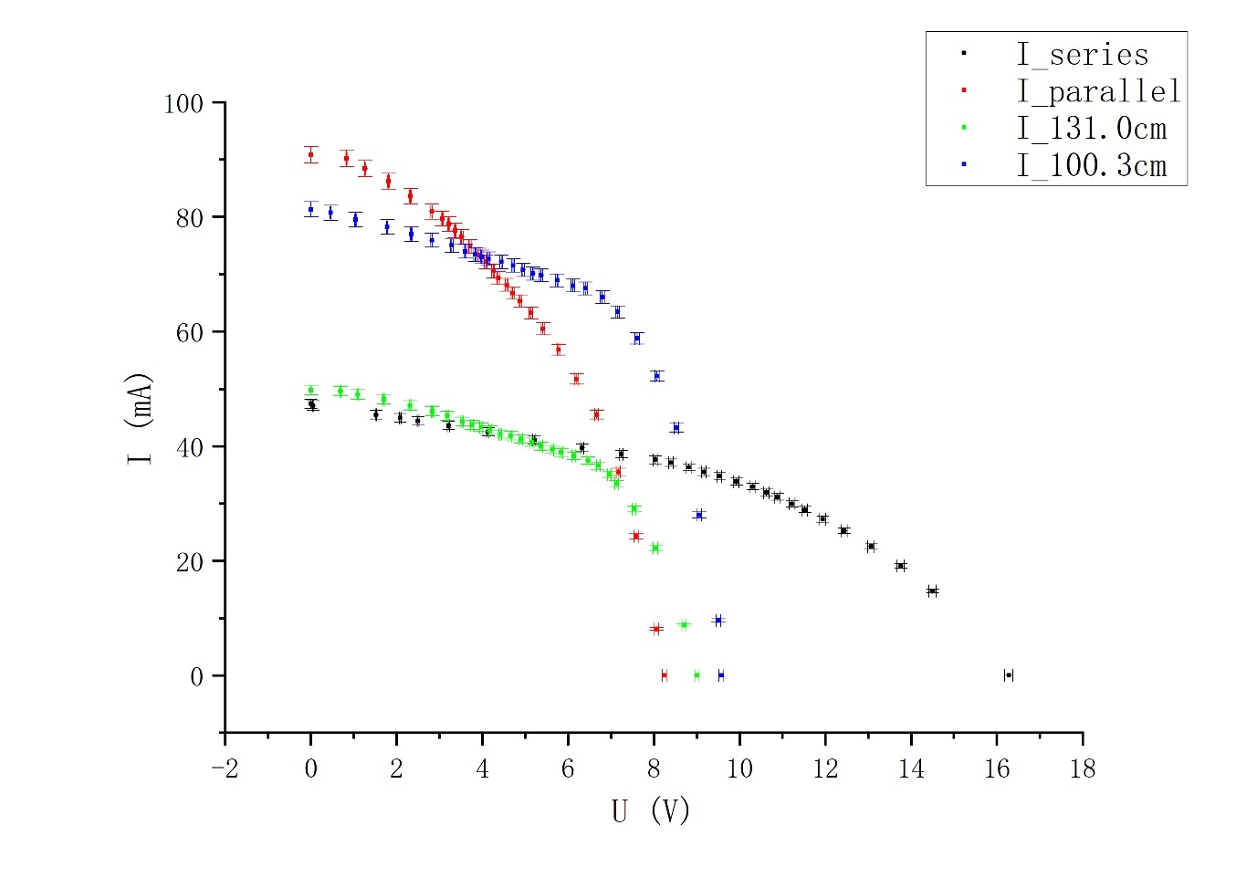Figure 4. *I-U* graph

Form this graph, we can see that with the increase of *U*, *I* first decreases slowly and after some point, it decreases quickly, which corresponds to the theoretical knowledge we learnt. Actually, this point indicates the maximum output power. In order to find $P_{m}$, we will further draw ­*P-U* and *P-R* graph. Moreover, we find that the closer the light source is, the more current it will generate. For the parallel and series connection, we find that more current is generated by the parallel connection while more voltage is generated by the series connection, and this corresponds to the basic knowledge of circuits.

According to the equation $P=UI$ and $R=\frac{V}{I}$, and with the help of Table 6 and 7, we can calculate *P* and *R* respectively, which are shown in Table 8 and 9.

|  |  |  |  |  |  |  |  |  |
| --- | --- | --- | --- | --- | --- | --- | --- | --- |
|  | Series | | | | Parallel | | | |
|  | *P* [W] | $u_{P}[±W$] | *R* [$Ω$] | $u_{R}[±Ω$] | *P* [W] | $u_{P}[±W$] | *R* [$Ω$] | $u_{R}[±Ω$] |
| 1 | 0.0024 | 0.0005 | 1.1 | 0.2 | 0.0749 | 0.0018 | 9.2 | 0.2 |
| 2 | 0.0692 | 0.0014 | 33.4 | 0.7 | 0.111 | 0.002 | 14.3 | 0.3 |
| 3 | 0.093 | 0.002 | 46.3 | 0.9 | 0.156 | 0.003 | 21.0 | 0.4 |
| 4 | 0.111 | 0.002 | 56.3 | 1.1 | 0.194 | 0.004 | 27.8 | 0.5 |
| 5 | 0.140 | 0.003 | 73.6 | 1.4 | 0.228 | 0.004 | 34.9 | 0.6 |
| 6 | 0.176 | 0.003 | 97 | 2 | 0.244 | 0.004 | 38.4 | 0.7 |
| 7 | 0.214 | 0.004 | 127 | 2 | 0.253 | 0.005 | 40.9 | 0.7 |
| 8 | 0.251 | 0.005 | 159 | 3 | 0.261 | 0.005 | 43.3 | 0.8 |
| 9 | 0.279 | 0.005 | 188 | 4 | 0.269 | 0.005 | 46.0 | 0.8 |
| 10 | 0.302 | 0.006 | 214 | 4 | 0.278 | 0.005 | 49.6 | 0.9 |
| 11 | 0.312 | 0.006 | 226 | 4 | 0.288 | 0.005 | 53.6 | 1.0 |
| 12 | 0.320 | 0.006 | 243 | 5 | 0.294 | 0.005 | 56.6 | 1.0 |
| 13 | 0.326 | 0.006 | 258 | 5 | 0.300 | 0.005 | 60.3 | 1.1 |
| 14 | 0.331 | 0.006 | 275 | 5 | 0.303 | 0.005 | 63.1 | 1.1 |
| 15 | 0.336 | 0.006 | 294 | 6 | 0.311 | 0.006 | 67.1 | 1.2 |
| 16 | 0.339 | 0.006 | 313 | 6 | 0.314 | 0.006 | 70.6 | 1.3 |
| 17 | 0.339 | 0.006 | 333 | 6 | 0.319 | 0.006 | 74.7 | 1.3 |
| 18 | 0.339 | 0.006 | 350 | 7 | 0.324 | 0.006 | 81 | 2 |
| 19 | 0.336 | 0.006 | 376 | 7 | 0.327 | 0.006 | 89 | 2 |
| 20 | 0.333 | 0.006 | 399 | 8 | 0.328 | 0.006 | 102 | 2 |
| 21 | 0.325 | 0.006 | 439 | 9 | 0.320 | 0.006 | 120 | 2 |
| 22 | 0.313 | 0.006 | 494 | 10 | 0.303 | 0.006 | 146 | 3 |
| 23 | 0.294 | 0.006 | 581 | 12 | 0.255 | 0.005 | 202 | 4 |
| 24 | 0.263 | 0.006 | 720 | 15 | 0.184 | 0.004 | 312 | 6 |
| 25 | 0.213 | 0.005 | 990 | 20 | 0.0653 | 0.0018 | 1000 | 30 |

Table 8. *P, U* and *R* for the *U* vs. *I* relation (series/parallel configuration)

|  |  |  |  |  |  |  |  |  |
| --- | --- | --- | --- | --- | --- | --- | --- | --- |
|  | 131.0 cm | | | | 100.3 cm | | | |
|  | *P* [W] | $u_{P}[±W$] | *R* [$Ω$] | $u_{R}[±Ω$] | *P* [W] | $u_{P}[±W$] | *R* [$Ω$] | $u_{R}[±Ω$] |
| 1 | 0.0342 | 0.0009 | 13.9 | 0.4 | 0.0371 | 0.0012 | 5.7 | 0.2 |
| 2 | 0.0534 | 0.0012 | 22.2 | 0.5 | 0.0827 | 0.0018 | 13.1 | 0.3 |
| 3 | 0.082 | 0.002 | 35.3 | 0.7 | 0.139 | 0.003 | 22.8 | 0.4 |
| 4 | 0.109 | 0.002 | 49.0 | 1.0 | 0.180 | 0.003 | 30.4 | 0.6 |
| 5 | 0.130 | 0.003 | 61.4 | 1.2 | 0.214 | 0.004 | 37.2 | 0.7 |
| 6 | 0.144 | 0.003 | 70.2 | 1.3 | 0.247 | 0.004 | 43.9 | 0.8 |
| 7 | 0.156 | 0.003 | 80 | 2 | 0.266 | 0.005 | 48.6 | 0.9 |
| 8 | 0.164 | 0.003 | 86 | 2 | 0.281 | 0.005 | 52.2 | 0.9 |
| 9 | 0.172 | 0.003 | 92 | 2 | 0.291 | 0.005 | 54.5 | 1.0 |
| 10 | 0.179 | 0.003 | 98 | 2 | 0.301 | 0.005 | 56.9 | 1.0 |
| 11 | 0.186 | 0.004 | 105 | 2 | 0.320 | 0.006 | 61.6 | 1.1 |
| 12 | 0.195 | 0.004 | 111 | 2 | 0.337 | 0.006 | 66.0 | 1.2 |
| 13 | 0.202 | 0.004 | 119 | 2 | 0.350 | 0.006 | 70.0 | 1.2 |
| 14 | 0.210 | 0.004 | 127 | 2 | 0.362 | 0.006 | 73.8 | 1.3 |
| 15 | 0.215 | 0.004 | 134 | 3 | 0.375 | 0.007 | 76.9 | 1.4 |
| 16 | 0.222 | 0.004 | 143 | 3 | 0.395 | 0.007 | 83 | 2 |
| 17 | 0.227 | 0.004 | 150 | 3 | 0.415 | 0.007 | 90 | 2 |
| 18 | 0.235 | 0.004 | 160 | 3 | 0.432 | 0.008 | 95 | 2 |
| 19 | 0.242 | 0.005 | 172 | 3 | 0.449 | 0.008 | 103 | 2 |
| 20 | 0.245 | 0.005 | 183 | 3 | 0.453 | 0.008 | 113 | 2 |
| 21 | 0.244 | 0.005 | 199 | 4 | 0.447 | 0.008 | 129 | 2 |
| 22 | 0.238 | 0.005 | 213 | 4 | 0.421 | 0.008 | 155 | 3 |
| 23 | 0.219 | 0.004 | 260 | 5 | 0.368 | 0.007 | 197 | 4 |
| 24 | 0.178 | 0.004 | 362 | 7 | 0.254 | 0.005 | 324 | 6 |
| 25 | 0.077 | 0.002 | 990 | 30 | 0.091 | 0.002 | 990 | 30 |

Table 9. *P, U* and *R* for the *U* vs. *I* relation (131.0 cm/100.3 cm configuration)

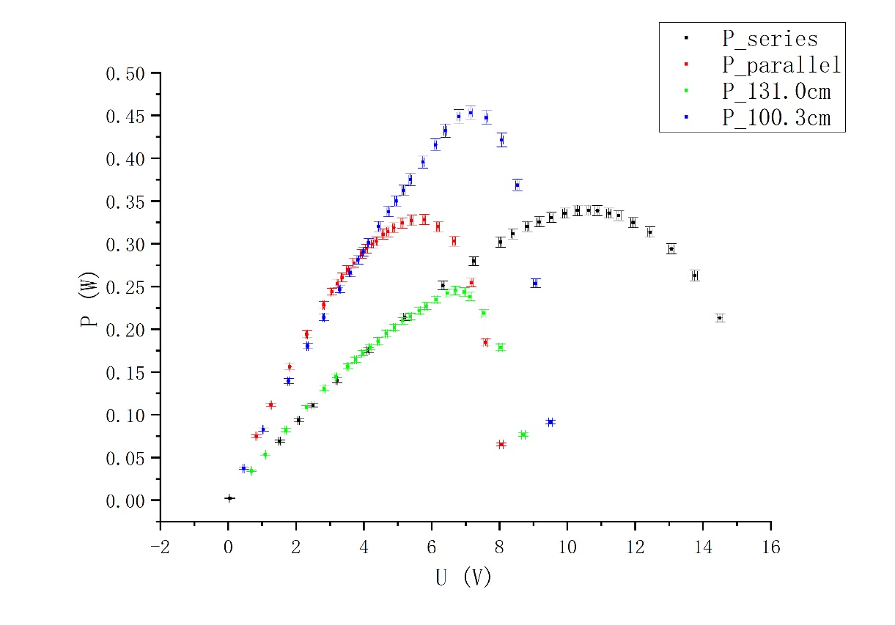Based on these two tables, we can get *P-U* and *P-R* graphs (Figure 5 and 6) respectively.

Figure 5. *P-U* graph

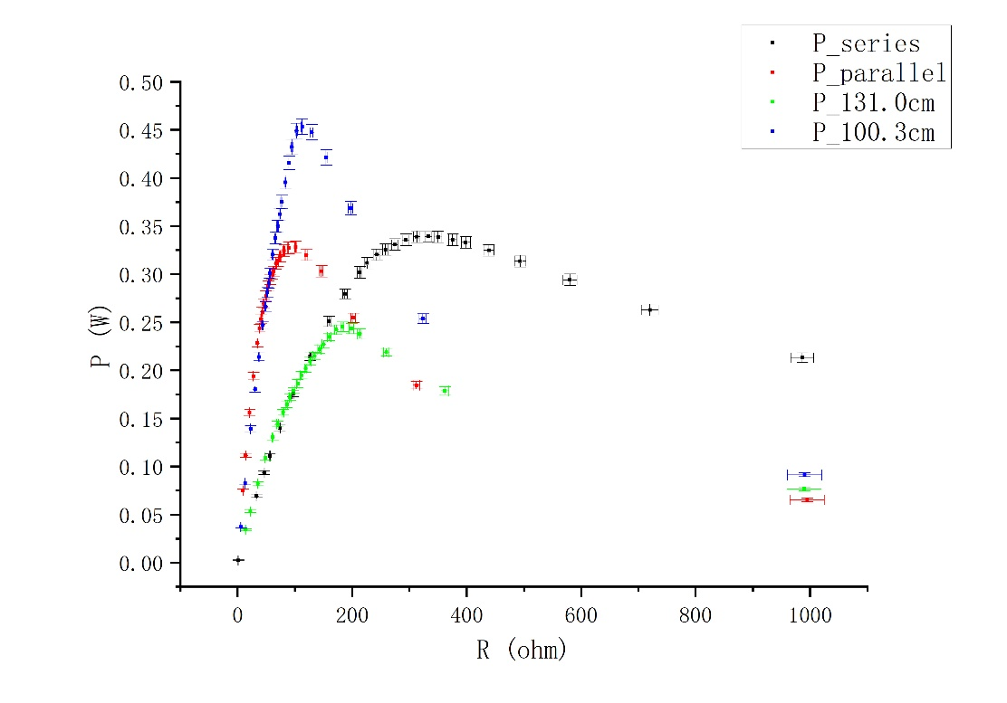We can see that, with the increase of *U*, *P* first increases and then decreases. Then there exists a peak that indicates the maximum power output. For the series and parallel connection, they have almost the same maximum output power, but it takes about two times voltage of the parallel connection for the series to get maximum output power. For the 131.0 cm and 100.3 cm, they almost at the same voltage to reach maximum power output. And the closer the light source is, the larger the maximum output power can be.

Figure 6. *P-R* graph

We can see that, with the increase of *R, P* first increases and then decreases. Then there exists a peak that indicates the maximum power output. For the series and parallel connection, they have almost the same maximum output power, but it takes about two times of resistance of the parallel connection for the series to get maximum output power. For the 131.0 cm and 100.3 cm, they almost at the same resistance to reach maximum power output. And the closer the light source is, the larger the maximum output power can be.

However, the resistance or the voltage needed for the 131.0 cm and 100.3 cm to achieve maximum power output are not exactly the same. We may consider that the inner resistance of the solar cell will be affected by temperature because the closer the light source, the more heat will be generated and influence the inner resistance of the solar cell.

Finally, we can calculate the *FF* and $η$ using the following equations:

$$FF=\frac{P_{m}}{V_{oc}I_{sc}}=\frac{V_{m}I_{m}}{V_{oc}I_{sc}}$$

$$η=\frac{P_{m}}{P_{in}}×100\%$$

Then, we get the table below (Table 10).

|  |  |  |  |  |  |  |  |  |
| --- | --- | --- | --- | --- | --- | --- | --- | --- |
|  | $V_{oc}$ [V] | $u_{V_{oc}}$ [ $±V]$ | $$I_{sc}$$ [mA] | $$u_{Isc}$$ [ $±mA]$ | $$P_{m}$$ [W] | $$u_{P_{m}}$$ [ $±W]$ | $$V_{m}$$ [V] | $$u_{V_{m}}$$ [ $±V]$ |
| Series | 16.28 | 0.09 | 47.4 | 0.8 | 0.339 | 0.006 | 10.63 | 0.06 |
| Parallel | 8.24 | 0.05 | 90.8 | 2.5 | 0.328 | 0.006 | 5.78 | 0.04 |
| 131.0cm | 9.01 | 0.06 | 49.8 | 0.8 | 0.245 | 0.005 | 6.70 | 0.04 |
| 100.3cm | 9.58 | 0.06 | 81.3 | 1.3 | 0.453 | 0.008 | 7.15 | 0.05 |

|  |  |  |  |  |  |  |  |  |
| --- | --- | --- | --- | --- | --- | --- | --- | --- |
|  | [mA] | $$u_{I_{m}}$$ [ $±mA]$ | $$R$$ [$Ω$] | $$u_{R}$$ [ $±Ω]$ | *FF* | $$u_{FF}$$ | $$η$$ | $$u_{η}$$ |
| Series | 31.9 | 0.6 | 333 | 6 | 0.439 | 0.011 | 1.76% | 0.13% |
| Parallel | 56.8 | 1.0 | 102 | 2 | 0.439 | 0.015 | 1.70% | 0.13% |
| 131.0cm | 36.6 | 0.6 | 183 | 3 | 0.547 | 0.015 | 2.5% | 0.2% |
| 100.3cm | 63.4 | 1.1 | 113 | 2 | 0.582 | 0.014 | 4.2% | 0.2% |

Table 10. Other important variables

From the above table, we find that $η$ for 100.3 cm is relatively larger. Considering the procedures, I think that during our experiment, we have moved the light source about 20 % closer to the photovoltaic. However, when we try to measure the solar power with a solar power meter, we find there are some places out of the range of the meter. Therefore, the actual $P_{in}$ may be larger. In order to solve this problem, we can move the light source about 20% further than the original distance.

1. **Conclusion**

In this lab, we get familiar with the working principle of a solar cell, and study the current-voltage (*I-V*) characteristics. We measured the open circuit voltage and short circuit current. Then we change the resistance and get the *I-V* data. Then, with the help of the computer, we plot ­*I-V, P-V* and *P-R* curves. Watching these figures, we have some interesting finds, which have been talked in the “Results and discussion” part.

However, in the experiment, we have made some mistakes. For example, when we move the light source about 20 % closer to the photovoltaic, we find that some places on the photovoltaic is actually out of the range of the solar power meter, which will lead to the inaccuracy of our $P_{in}$. Therefore, in the future experiment, I recommend that students had better move the photovoltaic about 20% further than the original distance.

1. **References**

[1] Exercise 3 - lab manual [rev 5.2], UM-JI SJTU. Edited by Qin Tian, Zheng Huan, Li Yingyu, Li Tiantian, Mateusz Krzyzosiak.

[2] Uncertainty analysis handbook, UM-JI SJTU.

1. **Uncertainty analysis**

**A.1. Uncertainty for $P_{in}$**

Since length and width are measured directly, there is only type B uncertainty.

$$u_{m}=∆_{B}= 0.1 cm$$

Since $S=L×W$ in our experiment,

$$u_{S}=\sqrt{{(\frac{∂S}{∂L}u_{L})}^{2}+{(\frac{∂S}{∂W}u_{W})}^{2}}=\sqrt{{(Wu_{L})}^{2}+{(Lu_{W})}^{2}}=3 {[cm}^{2}]$$

For the uncertainty of average value of solar power measurements

$$∆_{A}=\frac{t_{0.95}}{\sqrt{6}}\sqrt{\frac{1}{5}\sum_{i=1}^{6}{{\left(p_{i}-\overline{P_{131.0}}\right)}^{2}}}=9.11 [W/m^{2}]$$

$$∆_{B}=10 W/m^{2}$$

$$u_{P103.0}=\sqrt{∆_{A}^{2}+∆_{B}^{2}}=13.5 [W/m^{2}]$$

Similarly, $$u_{P100.3}=\sqrt{∆_{A}^{2}+∆_{B}^{2}}=10.1 [W/m^{2}]$$

Since $P_{in}=S×\overline{P}$, we can get

$$u_{pin1}=\sqrt{{(\frac{∂P_{in1}}{∂S}u_{S})}^{2}+{(\frac{∂P_{in2}}{∂\overline{P}}u_{\overline{P}})}^{2}}=0.7 [W]$$

Similarly, $$u_{pin2}=0.6 [W]$$

**A.2. Uncertainty for measurement data**

These data are measured directly, therefore, there is only type B uncertainty. For DC voltage, $u_{m}=∆_{B}=±0.5\%+0.01 [V]$, and for DC current, $u_{m}=∆_{B}=±$ 1.5%+0.1 [mA]. Therefore, their uncertainty can be calculated below.

|  |  |  |  |  |
| --- | --- | --- | --- | --- |
|  | Single device at 131.0 cm | Single device at 100.3 cm | Series | Parallel |
| $U_{oc}$ [V] | 0.06 | 0.06 | 0.09 | 0.05 |
| $I_{sc}$ [mA] | 0.8 | 1.3 | 0.8 | 1.5 |

Table 11. Uncertainty for measurement data for $U_{oc}$ and $I_{sc}$

|  |  |  |  |  |
| --- | --- | --- | --- | --- |
|  | Series | | Parallel | |
|  | *U* uncertainty [V] | *I* uncertainty [mA] | *U* uncertainty [V] | *I* uncertainty [mA] |
| 1 | 0.01 | 0.8 | 0.01 | 1.5 |
| 2 | 0.02 | 0.8 | 0.02 | 1.4 |
| 3 | 0.02 | 0.8 | 0.02 | 1.4 |
| 4 | 0.02 | 0.8 | 0.02 | 1.4 |
| 5 | 0.03 | 0.8 | 0.02 | 1.3 |
| 6 | 0.03 | 0.7 | 0.03 | 1.3 |
| 7 | 0.04 | 0.7 | 0.03 | 1.3 |
| 8 | 0.04 | 0.7 | 0.03 | 1.3 |
| 9 | 0.05 | 0.7 | 0.03 | 1.2 |
| 10 | 0.05 | 0.7 | 0.03 | 1.2 |
| 11 | 0.05 | 0.7 | 0.03 | 1.2 |
| 12 | 0.05 | 0.6 | 0.03 | 1.2 |
| 13 | 0.06 | 0.6 | 0.03 | 1.2 |
| 14 | 0.06 | 0.6 | 0.03 | 1.1 |
| 15 | 0.06 | 0.6 | 0.03 | 1.1 |
| 16 | 0.06 | 0.6 | 0.03 | 1.1 |
| 17 | 0.06 | 0.6 | 0.03 | 1.1 |
| 18 | 0.06 | 0.6 | 0.04 | 1.0 |
| 19 | 0.07 | 0.5 | 0.04 | 1.0 |
| 20 | 0.07 | 0.5 | 0.04 | 1.0 |
| 21 | 0.07 | 0.5 | 0.04 | 0.9 |
| 22 | 0.07 | 0.5 | 0.04 | 0.8 |
| 23 | 0.08 | 0.4 | 0.05 | 0.6 |
| 24 | 0.08 | 0.4 | 0.05 | 0.5 |
| 25 | 0.08 | 0.3 | 0.05 | 0.2 |

Table 12. Uncertainty for measurement data for the *U* vs. *I* relation (series/parallel configuration)

|  |  |  |  |  |
| --- | --- | --- | --- | --- |
|  | 131.0 cm | | 100.3 cm | |
|  | *U* uncertainty [V] | *I* uncertainty [mA] | *U* uncertainty [V] | *I* uncertainty [mA] |
| 1 | 0.01 | 0.8 | 0.01 | 1.3 |
| 2 | 0.02 | 0.8 | 0.02 | 1.3 |
| 3 | 0.02 | 0.8 | 0.02 | 1.3 |
| 4 | 0.02 | 0.8 | 0.02 | 1.3 |
| 5 | 0.02 | 0.8 | 0.02 | 1.2 |
| 6 | 0.03 | 0.8 | 0.03 | 1.2 |
| 7 | 0.03 | 0.8 | 0.03 | 1.2 |
| 8 | 0.03 | 0.8 | 0.03 | 1.2 |
| 9 | 0.03 | 0.7 | 0.03 | 1.2 |
| 10 | 0.03 | 0.7 | 0.03 | 1.2 |
| 11 | 0.03 | 0.7 | 0.03 | 1.2 |
| 12 | 0.03 | 0.7 | 0.03 | 1.2 |
| 13 | 0.03 | 0.7 | 0.03 | 1.2 |
| 14 | 0.04 | 0.7 | 0.04 | 1.2 |
| 15 | 0.04 | 0.7 | 0.04 | 1.1 |
| 16 | 0.04 | 0.7 | 0.04 | 1.1 |
| 17 | 0.04 | 0.7 | 0.04 | 1.1 |
| 18 | 0.04 | 0.7 | 0.04 | 1.1 |
| 19 | 0.04 | 0.7 | 0.04 | 1.1 |
| 20 | 0.04 | 0.6 | 0.05 | 1.1 |
| 21 | 0.04 | 0.6 | 0.05 | 1.0 |
| 22 | 0.05 | 0.6 | 0.05 | 0.9 |
| 23 | 0.05 | 0.5 | 0.05 | 0.7 |
| 24 | 0.05 | 0.4 | 0.06 | 0.5 |
| 25 | 0.05 | 0.2 | 0.06 | 0.2 |

Table 13. Uncertainty for measurement data for the *U* vs. *I* relation (131.0 cm/100.3 cm configuration)

**A.3. Uncertainty for *P* and *R***

Since $P=UI$ and $R=\frac{U}{I}$, we can get that

$$u_{P}=\sqrt{{(\frac{∂P}{∂U}u_{U})}^{2}+{(\frac{∂P}{∂I}u_{I})}^{2}}=\sqrt{{(Iu_{U})}^{2}+{(Uu_{I})}^{2}}$$

$$u_{R}=\sqrt{{(\frac{∂R}{∂U}u_{U})}^{2}+{(\frac{∂R}{∂I}u_{I})}^{2}}=\sqrt{{(\frac{u_{U}}{I})}^{2}+{(\frac{U}{I^{2}}u_{I})}^{2}}$$

Then, we can get the following two tables.

|  |  |  |  |  |  |  |  |  |
| --- | --- | --- | --- | --- | --- | --- | --- | --- |
|  | Series | | | | Parallel | | | |
|  | *P* [W] | $u_{P}[±W$] | *R* [$Ω$] | $u_{R}[±Ω$] | *P* [W] | $u_{P}[±W$] | *R* [$Ω$] | $u_{R}[±Ω$] |
| 1 | 0.0024 | 0.0005 | 1.1 | 0.2 | 0.0749 | 0.0018 | 9.2 | 0.2 |
| 2 | 0.0692 | 0.0014 | 33.4 | 0.7 | 0.111 | 0.002 | 14.3 | 0.3 |
| 3 | 0.093 | 0.002 | 46.3 | 0.9 | 0.156 | 0.003 | 21.0 | 0.4 |
| 4 | 0.111 | 0.002 | 56.3 | 1.1 | 0.194 | 0.004 | 27.8 | 0.5 |
| 5 | 0.140 | 0.003 | 73.6 | 1.4 | 0.228 | 0.004 | 34.9 | 0.6 |
| 6 | 0.176 | 0.003 | 97 | 2 | 0.244 | 0.004 | 38.4 | 0.7 |
| 7 | 0.214 | 0.004 | 127 | 2 | 0.253 | 0.005 | 40.9 | 0.7 |
| 8 | 0.251 | 0.005 | 159 | 3 | 0.261 | 0.005 | 43.3 | 0.8 |
| 9 | 0.279 | 0.005 | 188 | 4 | 0.269 | 0.005 | 46.0 | 0.8 |
| 10 | 0.302 | 0.006 | 214 | 4 | 0.278 | 0.005 | 49.6 | 0.9 |
| 11 | 0.312 | 0.006 | 226 | 4 | 0.288 | 0.005 | 53.6 | 1.0 |
| 12 | 0.320 | 0.006 | 243 | 5 | 0.294 | 0.005 | 56.6 | 1.0 |
| 13 | 0.326 | 0.006 | 258 | 5 | 0.300 | 0.005 | 60.3 | 1.1 |
| 14 | 0.331 | 0.006 | 275 | 5 | 0.303 | 0.005 | 63.1 | 1.1 |
| 15 | 0.336 | 0.006 | 294 | 6 | 0.311 | 0.006 | 67.1 | 1.2 |
| 16 | 0.339 | 0.006 | 313 | 6 | 0.314 | 0.006 | 70.6 | 1.3 |
| 17 | 0.339 | 0.006 | 333 | 6 | 0.319 | 0.006 | 74.7 | 1.3 |
| 18 | 0.339 | 0.006 | 350 | 7 | 0.324 | 0.006 | 81 | 2 |
| 19 | 0.336 | 0.006 | 376 | 7 | 0.327 | 0.006 | 89 | 2 |
| 20 | 0.333 | 0.006 | 399 | 8 | 0.328 | 0.006 | 102 | 2 |
| 21 | 0.325 | 0.006 | 439 | 9 | 0.320 | 0.006 | 120 | 2 |
| 22 | 0.313 | 0.006 | 494 | 10 | 0.303 | 0.006 | 146 | 3 |
| 23 | 0.294 | 0.006 | 581 | 12 | 0.255 | 0.005 | 202 | 4 |
| 24 | 0.263 | 0.006 | 720 | 15 | 0.184 | 0.004 | 312 | 6 |
| 25 | 0.213 | 0.005 | 990 | 20 | 0.0653 | 0.0018 | 1000 | 30 |

Table 14. Uncertainty for *P, U* and *R* for the *U* vs. *I* relation (series/parallel configuration)

|  |  |  |  |  |  |  |  |  |
| --- | --- | --- | --- | --- | --- | --- | --- | --- |
|  | 131.0 cm | | | | 100.3 cm | | | |
|  | *P* [W] | $u_{P}[±W$] | *R* [$Ω$] | $u_{R}[±Ω$] | *P* [W] | $u_{P}[±W$] | *R* [$Ω$] | $u_{R}[±Ω$] |
| 1 | 0.0342 | 0.0009 | 13.9 | 0.4 | 0.0371 | 0.0012 | 5.7 | 0.2 |
| 2 | 0.0534 | 0.0012 | 22.2 | 0.5 | 0.0827 | 0.0018 | 13.1 | 0.3 |
| 3 | 0.082 | 0.002 | 35.3 | 0.7 | 0.139 | 0.003 | 22.8 | 0.4 |
| 4 | 0.109 | 0.002 | 49.0 | 1.0 | 0.180 | 0.003 | 30.4 | 0.6 |
| 5 | 0.130 | 0.003 | 61.4 | 1.2 | 0.214 | 0.004 | 37.2 | 0.7 |
| 6 | 0.144 | 0.003 | 70.2 | 1.3 | 0.247 | 0.004 | 43.9 | 0.8 |
| 7 | 0.156 | 0.003 | 80 | 2 | 0.266 | 0.005 | 48.6 | 0.9 |
| 8 | 0.164 | 0.003 | 86 | 2 | 0.281 | 0.005 | 52.2 | 0.9 |
| 9 | 0.172 | 0.003 | 92 | 2 | 0.291 | 0.005 | 54.5 | 1.0 |
| 10 | 0.179 | 0.003 | 98 | 2 | 0.301 | 0.005 | 56.9 | 1.0 |
| 11 | 0.186 | 0.004 | 105 | 2 | 0.320 | 0.006 | 61.6 | 1.1 |
| 12 | 0.195 | 0.004 | 111 | 2 | 0.337 | 0.006 | 66.0 | 1.2 |
| 13 | 0.202 | 0.004 | 119 | 2 | 0.350 | 0.006 | 70.0 | 1.2 |
| 14 | 0.210 | 0.004 | 127 | 2 | 0.362 | 0.006 | 73.8 | 1.3 |
| 15 | 0.215 | 0.004 | 134 | 3 | 0.375 | 0.007 | 76.9 | 1.4 |
| 16 | 0.222 | 0.004 | 143 | 3 | 0.395 | 0.007 | 83 | 2 |
| 17 | 0.227 | 0.004 | 150 | 3 | 0.415 | 0.007 | 90 | 2 |
| 18 | 0.235 | 0.004 | 160 | 3 | 0.432 | 0.008 | 95 | 2 |
| 19 | 0.242 | 0.005 | 172 | 3 | 0.449 | 0.008 | 103 | 2 |
| 20 | 0.245 | 0.005 | 183 | 3 | 0.453 | 0.008 | 113 | 2 |
| 21 | 0.244 | 0.005 | 199 | 4 | 0.447 | 0.008 | 129 | 2 |
| 22 | 0.238 | 0.005 | 213 | 4 | 0.421 | 0.008 | 155 | 3 |
| 23 | 0.219 | 0.004 | 260 | 5 | 0.368 | 0.007 | 197 | 4 |
| 24 | 0.178 | 0.004 | 362 | 7 | 0.254 | 0.005 | 324 | 6 |
| 25 | 0.077 | 0.002 | 990 | 30 | 0.091 | 0.002 | 990 | 30 |

Table 15. Uncertainty for *P, U* and *R* for the *U* vs. *I* relation (131.0 cm/100.3 cm configuration)

**A.4. Uncertainty for *FF* and $η$**

Since

$$FF=\frac{P_{m}}{V_{oc}I_{sc}}=\frac{V_{m}I_{m}}{V_{oc}I_{sc}}$$

$$η=\frac{P_{m}}{P_{in}}×100\%$$

We can get that $$u_{FF}=\sqrt{{(\frac{∂FF}{∂P_{m}}u_{P_{m}})}^{2}+{(\frac{∂FF}{∂V_{oc}}u_{V_{oc}})}^{2}+{(\frac{∂FF}{∂I_{sc}}u_{I_{sc}})}^{2}}=\sqrt{{(\frac{u_{P_{m}}}{V_{oc}I_{sc}})}^{2}+{(\frac{P_{m}u_{V_{oc}}}{{V_{oc}}^{2}I_{sc}})}^{2}+{(\frac{P_{m}u_{I_{sc}}}{V_{oc}{I_{sc}}^{2}})}^{2}}$$

$$u_{η}=\sqrt{{(\frac{∂η}{∂P_{m}}u_{P_{m}})}^{2}+{(\frac{∂η}{∂P_{in}}u_{P_{in}})}^{2}}=\sqrt{{(\frac{u_{P_{m}}}{P_{in}})}^{2}+{(\frac{P_{m}}{{P_{in}}^{2}}u_{P_{in}})}^{2}}$$

Therefore, we can get that

|  |  |  |  |  |
| --- | --- | --- | --- | --- |
|  | *FF* | $$u_{FF}$$ | $$η$$ | $$u_{η}$$ |
| Series | 0.439 | 0.011 | 1.76% | 0.13% |
| Parallel | 0.439 | 0.015 | 1.70% | 0.13% |
| 131.0cm | 0.547 | 0.015 | 2.5% | 0.2% |
| 100.3cm | 0.582 | 0.014 | 4.2% | 0.2% |

Table 15. Uncertainty for *FF* and $η$